EXP 13: Create a Virtual Machine with 1 CPU, 2GB RAM and 15GB storage disk using a Type 2 Virtualization Software using Vmware workstation.

AIM:
To create a virtual machine with 1 cpu, 2gb ram and 15gbstorage disk using a type
2 virtualization software using Vmware workstation.
PROCEDURE:
STEP 1:Dowload VMware workstation and installed as type 2hypervisor.
STEP2:Dowload ubuntu or tiny OS as iso image file.
STEP 3: In VMware workstation->create new VM.
STEP 4: Do the basic configuration settings.
STEP 5: Created tiny OS virtual machine.
STEP 6: Launch the VM.

IMPLEMENTATION:
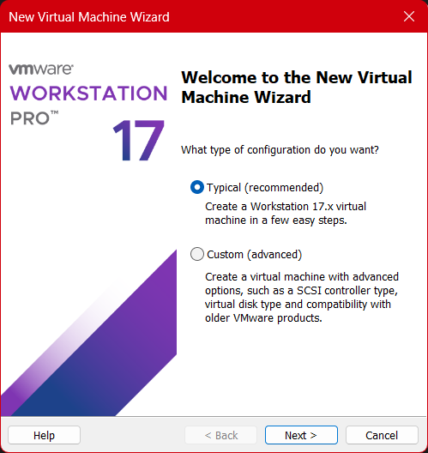

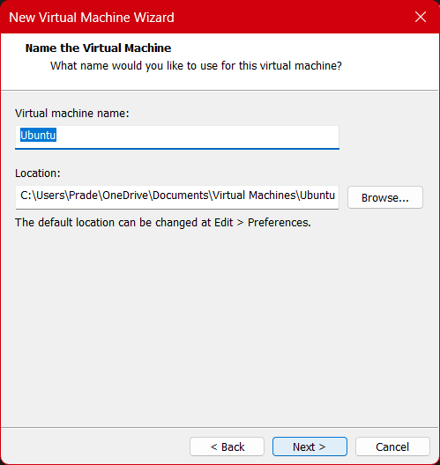
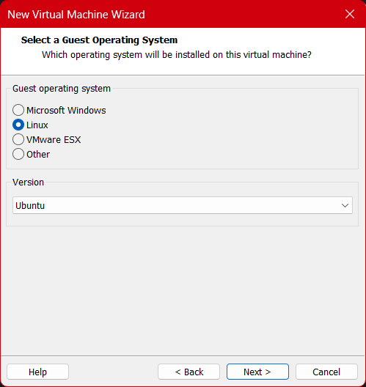

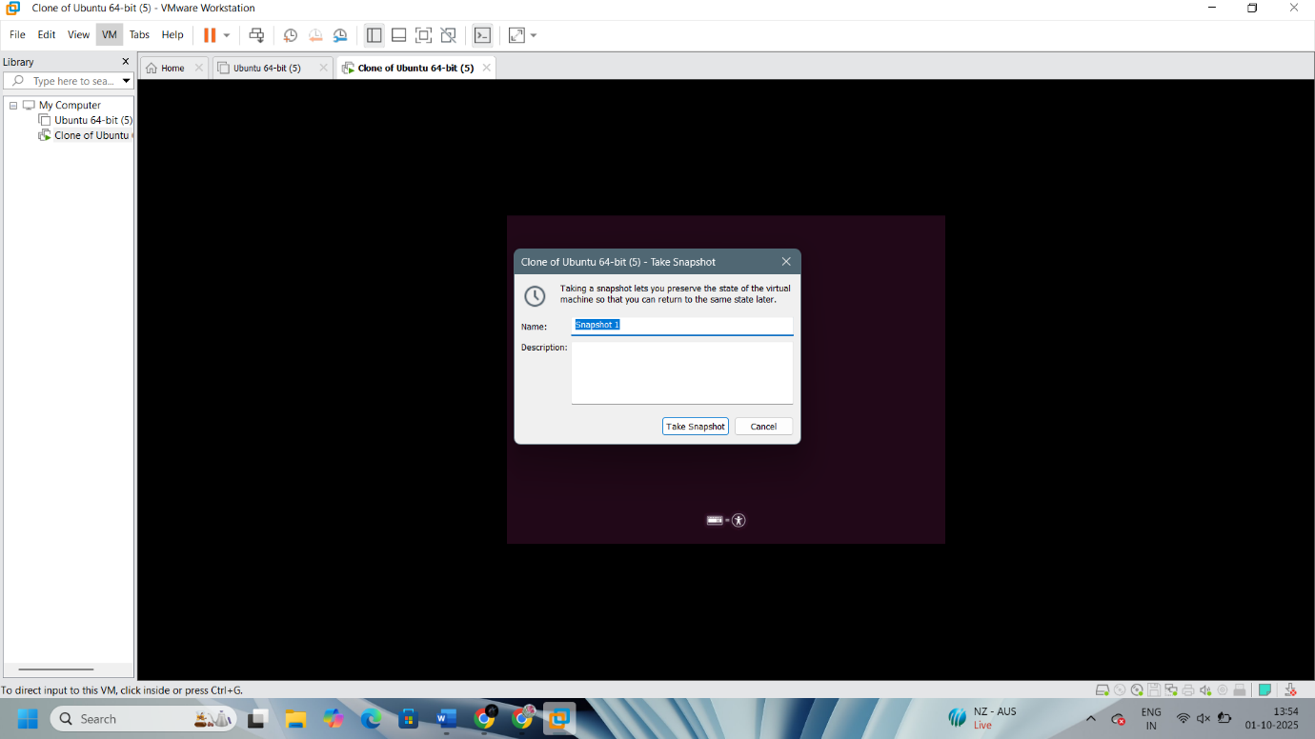

Result:
Virtual machine with 1 cpu, 2gb ram and 15gbstorage disk using a type
2 virtualization software has been created.

